Project Design Phase -2

|  |  |
| --- | --- |
| Team ID | PNT2022TMID01683 |
| ProjectName | Project-PlasmaDonorApplication |

**TECHNOLOGY ARCHITECTURE:**

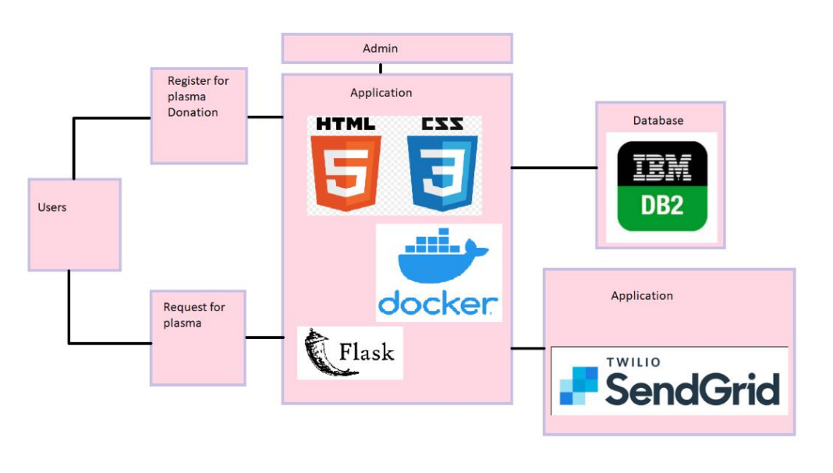

**HTML**

HTML (**H**yper**T**ext **M**arkup **L**anguage) is the code that is used to structure a web page and its content.

The main parts of our element are as follows:

1. The opening tag: This consists of the name of the element (in this case, p), wrapped in opening and closing angle brackets. This states where the element begins or starts to take effect — in this case where the paragraph begins.
2. The closing tag: This is the same as the opening tag, except that it includes a forward slash before the element name. This states where the element ends — in this case where the paragraph ends. Failing to add a closing tag is one of the standard beginner errors and can lead to strange results.
3. The content: This is the content of the element, which in this case, is just text.
4. The element: The opening tag, the closing tag, and the content together comprise the element.

**CSS**

CSS is not a programming language. It's not a markup language either. **CSS is a style sheet language.** CSS is what you use to selectively style HTML elements. For example, this CSS selects paragraph text, setting the color to red

In this project HTML and CSS is used for registration form to be attractive and aligned in structured format.

**DOCKER**

Docker is a set of platform as a service products that use OS-level virtualization to deliver software in packages called containers. it is virtual os placed above the os.

For example: we are creating a project and testing is one the phase in software development so testing is made on our project. Here docker comes in it provide all the dependencies and packages involved in our project it makes easy to test and deliver our project.

**FLASK**

Flask is a web framework written in python and it has built in development server and fast debugger. It is used for backend development and it provides tools, modules to develop the functionalities of an app rather than design look of it.

**IBM DATABASE**

The database enables you to access and manage server data through an application or a user interface. As well as providing access to and protection for your data, DB2 for IBM provides advanced functions, such as referential integrity and parallel database processing.